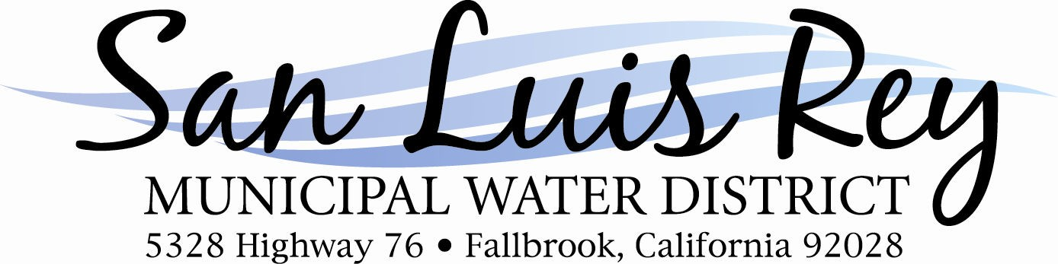

**Board of Directors**

William H. Pankey, President

Victor S. Pankey, Vice President Thomas F. Veysey, Secretary Christian Zaleschuk, Director

**District Legal Counsel**

Aleshire & Wynder, LLP

AGENDA

Regular Meeting of the

San Luis Rey Municipal Water District Wednesday, February 19, 2025 - 4:00 p.m.

at the

Pankey Ranch Office 5328 Highway 76

Fallbrook, California 92028

**NOTICE CONCERNING REGULARLY SCHEDULED MEETING**

The regularly scheduled meeting of the Board of Directors of the San Luis Rey Municipal Water District set for February 19, 2025, at 4:00 p.m. will not be held. The next regular meeting of the Board will be held on March 19, 2025, at 4:00

p.m. at the Pankey Ranch Office, 5328 Highway 76, Fallbrook, CA.